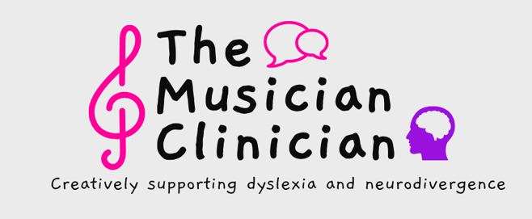

Complete Data Protection Statement / Privacy Notice

The Musician Clinician is a privately run, teaching, assessing and YouTube service.

Data Protection

The Musician Clinician stores certain types of records or personal and sensitive data (listed below), on their clients or service users, relating to the specific tasks for which The Musician Clinician has been contracted. This data will have been gathered with your consent and I will always ask your permission to retain it.

Once this data is gathered, The Musician Clinician is committed to its safe management through proportionate physical and technical means, in line with the EU General Data Protection Regulation (GDPR) of May 2018.

The Musician Clinician is registered with the ICO (Information Commissioners Office) as a ‘data controller’ and as such has a duty to ensure that all personal or sensitive data stored with me, is:

- Processed lawfully, fairly and transparently.
- Collected only for specific legitimate purposes.
- Adequate, relevant and limited to what is necessary.
- Accurate and kept up to date.
- Stored only as long as is necessary.
- Stored with appropriate security, accountability, integrity and confidentiality

Confidential Information:
- The personal information held by The Musician Clinician is confidential and will be treated as such.
- Information will not be shared with anyone without permission.
- Only in exceptional circumstances will information be disclosed to a third party, (e.g. If required by law.)

Secure Storage of Data:
- All records are stored securely.
- Teaching records will be stored for a period of five (5) years;
- Specialist diagnostic or assessment reports (along with the testing material used to compile such reports) will be stored for a period of six (6) years.
- After this time, all such records, will be destroyed, so it is strongly recommended that you keep your copies safe.

Details of the Information I hold:

- The information retained by The Musician Clinician will have been supplied by you or by others with your permission, or in the case of children under the age of 18, by those with parental consent.

- Only such information as will offer guidance in the preparation or delivery of our services (including taught sessions and Diagnostic Assessment Reports), will be requested.

- Any information not listed here, but which in individual cases, it might be necessary to request, will be treated in the same secure and confidential manner.

The Musician Clinician may store, through proportionate physical and technical means, any or all of the following types of information.

Name, Date of Birth, address and contact details at the time of assessment

Summarised Family History

Academic History, Including details of the school, college, university or other academic establishment attended at the time of contact with The Musician Clinician.

Additional Academic Information Including examples of written work, supplied by a school, college, university, private tutor or other academic establishment.

Assessment Results Including handwritten test results, completed during assessment or taught sessions.

Details and results of any Assessments, undertaken prior to your meeting with The Musician Clinician.

Details of Medical History or Special Educational Need

Handwritten notes taken during taught sessions or diagnostic assessments

Personal Characteristics Including photographs, taken during the course of an assessment or taught session.

Information pertaining to Ethnic Origin

I hold this personal data in order to:

- Support the assessment and learning of our service users
- To monitor and report on their educational needs and progress.
- To provide appropriate pastoral care
- To periodically assess the quality of our services.
- To provide service users with additional information on services appropriate to their specialist support

I will not process personal or sensitive data for the purpose of direct marketing

How I use and store your information:

The personal information relating to my service users may be acquired from schools, colleges or universities; private tutors; Local Education Authorities (LEA), Family Members (usually parents or guardians) and, on occasion from The Department for Education (DfE).

Any information acquired by The Musician Clinician, during the preparation or delivery of my services, is deemed private and will be treated in the strictest confidence. As a result:
- I will not share information about my service users to anyone without their consent (or the consent of a parent/guardian, if the service user is under 18 years) unless the law allows or requires it.

- To ensure this, measures have been taken to store such information securely (either in paper form or electronically), through proportionate physical and technical means.

The Musician Clinician ensures that any and all staff and/or contractors working for me, will sign a Data Protection agreement, which prohibits them from releasing to unauthorised persons, any information acquired during the course of their employment.

- This includes information relating to service users and their families, other employees and the company itself.

The Musician Clinician also ensures that any independent contractors employed by me, are GDPR compliant and that they will handle any and all information within the guidelines laid out by our data protection policy and procedures.

Access to your Information:
- Service users of The Musician Clinician have the right to view their personal data and/or obtain copies of it.
- Service users of The Musician Clinician can at any time after the conclusion of the service, revoke their consent for the storage of such data.

Access Requests:

Service users, as ‘data subjects’ have certain rights under the GDPR, including the right of access to any personal data held about them by a data controller.

You may therefore request details of personal information which I hold about you. A small administration fee will be payable.

Any service user (or the parent/guardian of a child under the age of 18), wishing to obtain copies of the information held on them, should contact me at: hello@musicianclinician.com; telephone 07910490198 or write to The Musician Clinician, 7 Butlers Close, Bristol BS5 8AW.

